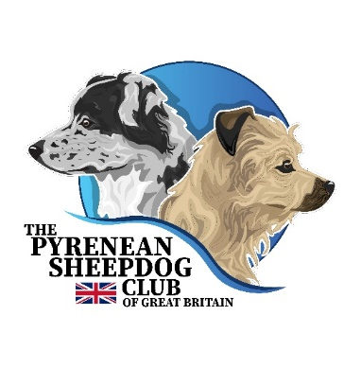

BOOKING FORM

Pyrenean Sheepdog

**Breed Appreciation Day**

Saturday 4th October 2025

9.30am to 4pm

*Greetham Community Centre,*

*Great Lane, Oakham LE15 7NG* . Speaker **M. Norbert Gainche**

*President of the French Club for the Breeds Pyrenees, ‘Reunion des Amateurs de Chiens Pyreneens’*

***The day will cover the long haired variety of the Pyrenean Sheepdog, and will have comparison references, the Breed Standard and information on the smooth haired variety.***

***Please Tick***

9.00 – 9.30 Welcome & Coffee

9.30 start- BAD - Breed Appreciation Presentation . . . . . . . . . . . . . . . . . . . . . . . . £25

BAD & *MCE – *Multiple Choice Exam* . . . . . . . . . . . . . . . . . . . . . . . . . . . . . . . . . . . . . £30

BAD, *MCE & *MENTORING - *limited number of mentoring places available . . . .* £35

HANDS ON *ASSESSMENT F*or those looking to apply for Grandfathering Rights*

*{ PSD (long haired) numbers judged needed for Grandfathering rights is 30 }* . . . £10

**Total…………………………**

Lunch is included – but please tick if you wish to have Lunch so we know numbers ………………………….

*\*Anticipated timings -subject to change, exact timings given when number of candidates confirmed.*

*Breed Presentation 9.30am – Coffee - MCE & ‘Hands On’ -- Mentoring P.M. after lunch*

Bank details – The Pyrenean Sheep Dog Club of Great Britain

A/C no 93205053 Sort Code 20 – 52 – 69

-------------------------------------------------------------------------------------------------------------------------------

Name …

Address …

Email …

phone …

Places limited - to register & book a place, applications by 1st September 2025

contact the Breed Education Coordinator [**PSDClubGB@mail.com**](mailto:PSDClubGB@mail.com)